Learning Experience:

Angles and Circles

When planning, include the following:

Models (Concrete—Semi-Concrete—Semi-Abstract—Abstract)

Problems/Situations

Questions

AKS:

41.MD.5 recognize that an angle is measured with reference to a circle with its center at the common endpoint of the rays, by considering the fraction of the circular arc between the points where the two rays intersect the circle; an angle that turns through 1/360 of a circle is called a "one-degree angle", and can be used to measure angles

Vertical Alignment:

5th
39.G.3 demonstrate that attributes belonging to a category of two-dimensional figures also belong to all subcategories of that category (e.g., all rectangles have four right angles and squares are rectangles so all squares have four right angles)
40.G.4 classify two-dimensional figures in a hierarchy based on properties
3rd
42.G.1 identify, draw, examine, and classify quadrilaterals (including rhombuses, rectangles, squares, parallelograms, and trapezoids)
43.G.1 compare and contrast the attributes of quadrilaterals, and categorize quadrilaterals based on shared attributes

Standards for Mathematical Practice:

1. Make sense of problems and persevere in solving them.
2. Reason abstractly and quantitatively.
3. Construct viable arguments and critique the reasoning of others.
4. Model with mathematics.
5. Use appropriate tools strategically.
6. Attend to precision.
7. Look for and make use of structure.
8. Look for and express regularity in repeated reasoning.

Materials:

Exploring Angles Around the Room
- student math journals
- Angle Explorer for each pair of students
Paper Plate Protractor
- 2- Hefty® Styrofoam plates per student (or generic with 36 thumbprints along the edge)
- Glue stick
- Scissors
- Pencil
- Sharpie marker
- Ruler
- 1- 5.5-6inch colored paper circle

- Hamster Champs by Stuart Murphy
- Sir Cumference and the Great Knights of Angleland by Cindy Neuschwander

Vocabulary:

Angle
Ray
Endpoint
Degree of an angle
Acute
Obtuse
Right
Protractor
Center of a circle
Radius
Diameter
Arc
Fraction

Essential Question:

What is an angle and how can we measure angles?
How are a circle and an angle related?
How do we measure angles using a protractor?

Activating Strategy:
Read a book to introduce students to the concept of angles:

Hamster Champs by Stuart Murphy
Daredevil hamsters use a protractor to measure angles to build a ramp that will keep them ahead of Hector the cat.

Sir Cumference and the Great Knights of Angleland by Cindy Neuschwander
Radius, son of Sir Cumference and Lady Di of Ameter, uses a circular medallion, a protractor, to find his way while hunting for his missing king.

*As you are reading aloud, students should be writing down any math vocabulary they hear in their math journals. You can have students draw a vertical line down a page in their notebook and label the two columns with “Math Words I Know” and “Math Words I Want to Know.” After you finish the book, allow students to share the words they found. Have a conversation about the words they found to review words students know and preview upcoming vocabulary.

Instructional Activity: (these tasks can be implemented over the course of several days)
1. Exploring Angles Around the Room

Angles are geometric shapes composed of two rays that are infinite in length. Review angles as acute (less than the measure of a right angle) and obtuse (greater than the measure of a right angle). Have students draw representations of each type of angle in their math journal.

Students can understand this concept by using an “Angle Explorer (two strips of cardboard attached with a brass fastener). Teachers can have these premade for the students or students can assemble them. Simply connect two 5 inch strips of cardstock or tagboard with a brad. See picture below.

They can use the angle explorer to get a feel of the relative size of angles as they rotate the cardboard strips around. Students can compare angles to determine whether an angle is acute or obtuse. This will allow them to have a benchmark reference for what an angle measure should be when using a tool such as a protractor or an angle ruler. Provide students with the already prepared “Angle Explorers.” Using their prior knowledge, students can search the room for angles. The teacher can designate certain items in the room for students to explore with their angle explorer. They should record their findings in their math journals.

Then, have them respond in their journal to the following questions:
1. What did you notice about each angle?
2. What mathematical connections did you make?
3. Can you draw a model to represent what you saw?
4. What do you understand now that you didn’t before?
5. Is there anything that you don’t understand?

2. Vocabulary

Students should add new vocabulary words to their math journal. The teacher will guide the students in recording the new vocabulary and a visual representation of the words. Refer to this website for vocabulary links. Click on both links for Vocabulary Cards 4th Grade.

http://www.graniteschools.org/depart/teachinglearning/curriculuminstruction/math/Pages/MathematicsVocabulary.aspx

3. Paper Plate Protractor
Students will create a protractor using paper plates. See directions below.

1) Glue the colored circle in the center of one of the plates.

2) Use a ruler to find the center of the plate and mark it with a pencil.

3) Stack the two plates together so that the thumbprints are nested on top of each other.

4) Use scissors to make a cut on the edge of one thumbprint to the center of the circle. *It is important that the plates are aligned so that the cut is on the edge of the thumbprint and NOT inside the thumbprint.

5) Separate the plates and number the thumbprints on the white plate starting with the thumbprint immediately to the right of the cut. Count by 10s from 10 to 360 going clockwise.

6) Insert one plate through the other along the cut line. Angles are formed by the 2 cuts (rays) and the center of the circle.

Discuss the definition of an arc in relationship to circles. Explain that an arc is a fractional part of a circle. For example, a 90 degree angle creates an arc that is one-fourth of the circle.

Now explore the protractors with the students by having them answer the questions below in their math journals.

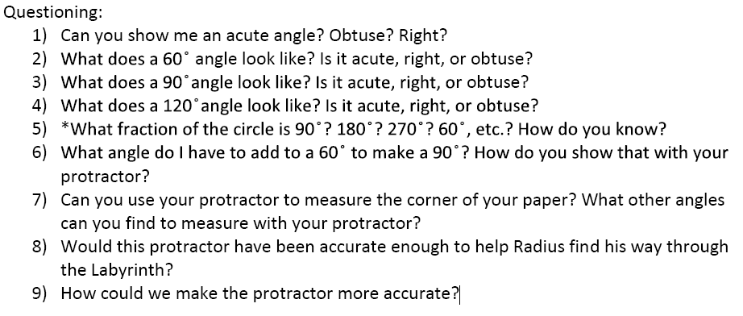
- Expanding the experience

Introduce students to using a real protractor. Students can measure angles online at:
http://www.amblesideprimary.com/ambleweb/mentalmaths/protractor.html

Students can identify types of angles by playing “What is my Name Worth?”
See attached file for game sheet.

- Extending the experience

Students can visit this website to play an angle review game (Banana Hunt):
http://www.oswego.org/ocsd-web/games/bananahunt/bhunt.html

The teacher should work with struggling students in a small group as they play the game. The other students can play the game independently.

Summarizing:

In their math journals, students should answer the following questions:

1. How do I use a protractor to measure an angle?
2. Draw a circle and create a 240 degree angle. What fractional part of the circle does its arc equal? How do you know?
3. What is the most important thing you learned?
4. Is there anything you don’t understand?

Did your plans you include the following?

Models (Concrete—Semi-Concrete—Semi-Abstract—Abstract)

Problems/Situations

Questions

