Learning Experience:

Lovely Line Plots

When planning, include the following:

Models (Concrete—Semi-Concrete—Semi-Abstract—Abstract)

Problems/Situations

Questions

AKS:

39.MD.4 : Make a line plot to display a data set of measurements in fractions of a unit (1/2, 1/4, 1/8). Solve problems involving addition and subtraction of fractions by using information presented in line plots.

Vertical Alignment:
5th:
21.NF.5 relate the principle of fraction equivalence, a/b = (n x a)/(n x b), to the effect of multiplying a/b by 1
29.MD.2 make a line plot to display a data set of measurements in fractions of a unit (1/2, 1/4, 1/8) and solve problems using the line plot data

3rd:
20.NF.3 explain equivalence of fractions in special cases and compare fractions by reasoning about their size
22.NF.3 recognize and generate simple equivalent fractions (e.g., 1/2 = 2/4, 4/6 = 2/3); explain why the fractions are equivalent by using a visual fraction model
30.MD.4 generate measurement data by measuring lengths to the nearest quarter inch, half inch and millimeter in addition to the previously learned inch, foot, yard, centimeter and meter
31.MD.4 create line plots showing measurement data where the horizontal scale is marked off in appropriate units— whole numbers, halves, or quarters

Standards for Mathematical Practice:

1. Make sense of problems and persevere in solving them.
2. Reason abstractly and quantitatively.
3. Construct viable arguments and critique the reasoning of others.
4. Model with mathematics.
5. Use appropriate tools strategically.
6. Attend to precision.
7. Look for and make use of structure.
8. Look for and express regularity in repeated reasoning.

Materials:

Book: An Inchworm and A Half by Elinor J. Pinczes
Sentence strips
Item cards for whole group activity (appendix 1)
Measurement cards for small group activity (appendix 2)
8 sided dice or spinners in 8 sections
Yarn
Index cards
White boards/markers
Color tiles
Ruler
Kidspiration attachment

Vocabulary:
line plot
data set
measurement in fractions of a unit
problem solving
addition
subtraction
fraction
plots
equivalent

Essential Question:

How do I make a line plot to display a data set?

How can I use a line plot to solve problems involving addition and subtraction of fractions?

Activating Strategy:

Read: An Inchworm and A Half by Elinor J. Pinczes

Review small measurements of an inch, ½ inch, ¼ inch, 1/8 inch.

Instructional Activity:

- Lay out a large line plot from 0-1 in increments of 1/8 inch across an open space in your classroom using sentence strips.
- Pass out cards for each student of various items (see appendix 1).
- The students will come up to the line plot and stand behind their appropriate measurement according to their card. This will create a human line plot.

Questioning:
- How many objects are 3/8 inch long? 7/8 inch?
- What amount on the line plot has the most objects? the least?
- If I add all the objects together, how many do we have in all?
- If we added the objects at 1/8 inch to the number of objects at 7/8 inch, how many will I have in all? What number sentence goes along with this scenario?
- If I take all the objects in the 8/8 inch row and I remove 2 of them, how many will I have left? What number sentence goes along with this scenario?
- Why aren’t there any objects that are equal to 0/8 inch on our line plot?
- What fraction(s) are equal to 4/8 inch? 2/8 inch? 6/8 inch? 8/8 inch? How do you know?

Expanding the experience:

Create a center for the students using 8 sided dice or a spinner divided into 8 sections.
- The students will create their own number line using a precut piece of yarn and premade index cards from 0/8 inch to 8/8 inch.
- The students will take turn rolling or spinning a designated number of times to create a line plot. The line plot can be marked using color tiles.
- Once the line plot is created, the students will ask each other addition and subtraction questions using the information presented on the line plot.
- They will write the number sentence on their white boards as they go.
- When they feel they have exhausted their data questioning possibilities, they can respin/reroll to create a new line plot.

and/or

Have the students practice with measurement on their own using objects in their desk. The directions on the following website suggest measuring to the nearest ½ inch, but it can be modified to fit your students’ abilities. It could also be done with a prepared bucket of objects.
http://www.k-5mathteachingresources.com/support-files/objectsinmydesklineplot.pdf

and/or

Use Kidspiration to make a line plot using the following attachment. After creating their line plot, students will make up 5 questions about the data and include their answers. See attachment.

Extending the experience:

Small group activity:
- Have each student measure one item to the nearest 12th of an inch and write it on the line (see appendix 2).
- As a whole group create a frequency table.
- Have each student create their own line plot based on the data on a half sheet of paper. Make sure to talk about how to create an appropriate scale for the line plot. (Ex. What is the difference in length between the longest and shortest item? Does this help with creating an appropriate scale?)
- Other questions to ask: (can be answered on a wipe board)
  - If you combine the bowl and the bow tie what is the total measurement?
  - What two objects are about the same length?
  - What do you notice about the data?
    - What is the largest object?
    - What is the smallest object?
    - Is there a measurement which has the most objects? If so, which one?
    - Is there a measurement that does not belong with the others? What object is it?
    - Are these measurements realistic? Why or why not?
  - If you lined up all the objects together, what is the total measurement?
Summarizing:

Ticket out the door:
http://www.k-5mathteachingresources.com/support-files/lengthofantslineplot.pdf

or

4 Windows:
Take a piece of paper. Fold it into four pieces. Label it Facts, Feelings, Ideas, Questions. Have 4 questions to answer in the segments:
- Facts: Tell how you would use a line plot to organize data.
- Feelings: What was your favorite part? What were your challenges?
- Ideas: What does this activity make you want to try in math in the future?
- Questions: What questions do you still have about measurement, line plots, adding & subtracting fractions, or equivalent fractions?

Appendix 1

Button   | Bead  
Macaroni   | Bean  
Rice   | String  
Ice Cube    | Thumb Tack  
Seashell   | Staple  
Peanut   | Diamond  
Walnut   | Almond   
Flower   | Eraser  
Base Ten Unit   | Screw  
Fingernail   | Skittle  
Green Pea     | M&M  
Smarty   | Peppermint  

Appendix 2

- _____________________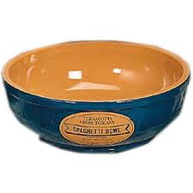.

b. ______________________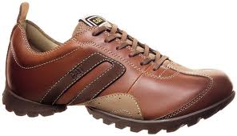
c..____________________ 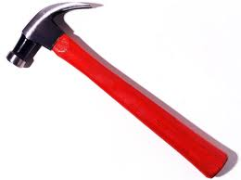
d. ________________________ 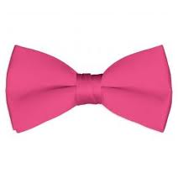
e. _______________________

f. ______________________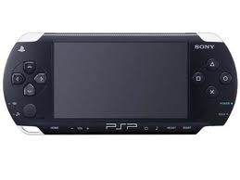
g. _____________________ 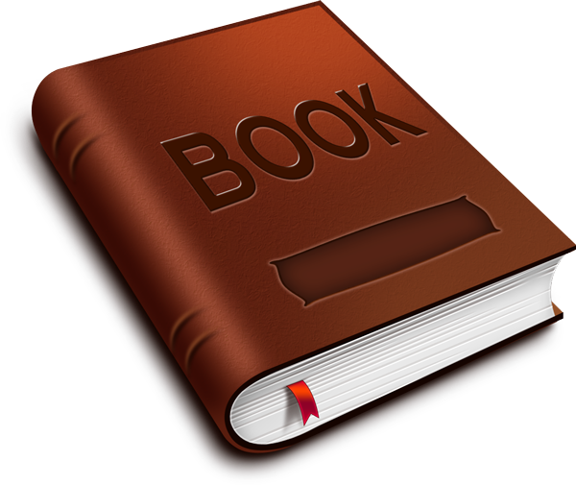
h. ____________________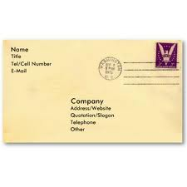

Did your plans you include the following?

Models (Concrete—Semi-Concrete—Semi-Abstract—Abstract)

Problems/Situations

Questions

