Learning Experience:

_________Division_________

When planning, include the following:

Models (Concrete—Semi-Concrete—Semi-Abstract—Abstract)

Problems/Situations

Questions

AKS:
NBT.6 Calculate whole number quotients and remainders with up to four-digit dividends and one-digit divisors using strategies based on place value, the properties of operations, and/or the relationship between multiplication and division. Illustrate and explain division calculations by using equations, rectangular arrays, and/or area models.

Vertical Alignment:

Standards for Mathematical Practice:

1. Make sense of problems and persevere in solving them.
2. Reason abstractly and quantitatively.
3. Construct viable arguments and critique the reasoning of others.
4. Model with mathematics.
6. Attend to precision.
7. Look for and make use of structure.
8. Look for and express regularity in repeated reasoning.

Materials:
Base Ten Blocks
Mimio
Counters
Math journals
Chart paper
Math literature (see list below of titles to use)

Vocabulary:
- Factor
- Multiple
- Divisor
- Dividend
- Quotient
- Remainder
- Equations
- Calculations
- Rectangular arrays
- Area models
Essential Question:
How do I find quotients and remainders? How do I use strategies to help me divide?

Activating Strategy:
Vocabulary word splash: Start with a quick word splash of division terms on chart paper and discuss terms briefly. As your division unit continues, use this chart and add to it. See the following chart for an example.
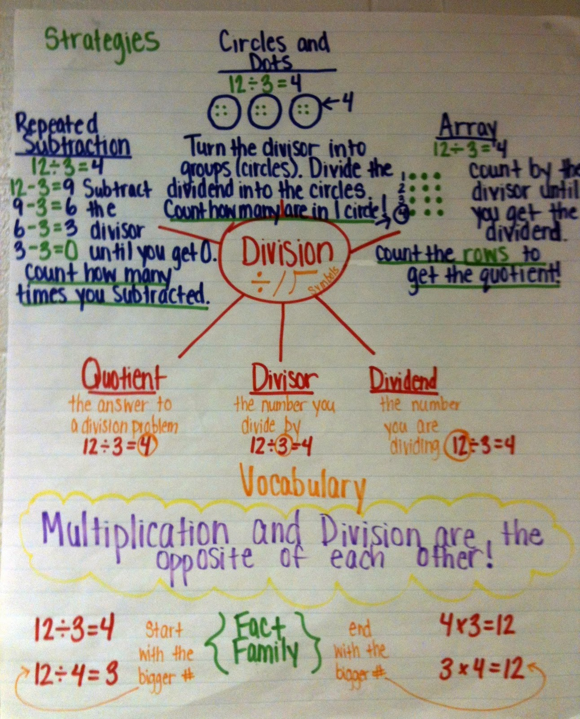

Read any of the following books as your opener:
The Doorbell Rang (easy)
The Great Divide by Suzanne Slade
Divide and Ride
Spaghetti and Meatballs for All by Marilyn Burns (more challenging)

Instructional Activity:
Equations:
Study Jams mini lesson: single digit divisor http://studyjams.scholastic.com/studyjams/jams/math/multiplication-division/single-digit-division.htm

Array:
Division Arrays game:
http://www.onekama.k12.mi.us/bjbrown/02-03/division_arrays_game.htm

Mimioconnect.com: “Division Array”

Area Models:
Watch You Tube: “Open Arrays in Division.m4v”
Division Split activity:
http://troupp-5ccgps.homestead.com/Grade_Level_Files/Fourth/Math/MathPage.html
Click on: Moving Through Concrete, Representational, Abstract, then NBT 5and6

Expanding/extending the experience:
- Partial quotients: MOCC powerpoint

- Enrichment example (two digit divisor): Khan Academy
Partial Quotient Division : An alternate to traditional long division http://www.khanacademy.org/math/arithmetic/multiplication-division/v/partial-quotient-division
- Additional Resources:
  - Think Math
  - Harcourt
  - Hands On Standards
    - 3-4: Lesson 12
  - Super Source: Base ten blocks
    - 3-4: “It’s In the Bag”
    - 5-6: “Fair Shares”
- Troup County common core lessons

Summarizing:
In your math journal, solve the equation: 486/5
Solve and explain using one of the methods learned.

Did your plans you include the following?

Models (Concrete—Semi-Concrete—Semi-Abstract—Abstract)

Problems/Situations

Questions

