Learning Experience:

Multiplying Fractions by a Whole Number

When planning, include the following:

Models (Concrete—Semi-Concrete—Semi-Abstract—Abstract)

Problems/Situations

Questions

AKS:

29.NF.4 solve word problems involving multiplication of a fraction by a whole number

Vertical Alignment:
3rd grade AKS

23.NF.3 express whole numbers as fractions and recognize fractions that are equivalent to whole numbers (e.g., express 3 in the form 3 = 3/1; recognize that 6/1 = 6; locate 4/4 and 1 at the same point of a number line diagram)

3.OA.3 apply multiplication and division (products or dividends 0 - 100) to solve word problems in situations involving equal groups, arrays and measurement quantities (e.g., by using drawings and equations with a symbol for the unknown number to represent the problem)**
5th grade AKS

50.T.NF.4* recognize a fraction a/b as a multiple of 1/b (e.g., use a visual fraction model to represent 5/4 as the product 5 x (1/4), recording the conclusion by the equation 5/4 = 5 x (1/4))

25.NF.7 interpret division of a unit fraction by a non-zero whole number and compute such quotients (e.g., create a story context for (1/3) ÷ 4 and use a visual fraction model to show the quotient. Use the relationship between multiplication and division to explain that (1/3) ÷ 4 = 1/12 because (1/12) x 4 = 1/3) Students able to multiply fractions in general can develop strategies to divide fractions in general, by reasoning about the relationship between multiplication and division. But division of a fraction by a fraction is not a requirement at this grade.

26.NF.7 interpret division of a whole number by a unit fraction and compute such quotients (e.g., create a story context for 4 ÷ (1/5) and use a visual fraction model to show the quotient. Use the relationship between multiplication and division to explain that 4 ÷ (1/5) = 20 because 20 x (1/5) = 4)

27.NF.7 solve real world problems involving division of unit fractions by non-zero whole numbers and division of whole numbers by unit fractions e.g., by using visual fraction models and equations to represent the problem. (For example, how much chocolate will each person get if 3 people share 1/2 lb of chocolate equally? How many 1/3-cup servings are in 2 cups of raisins?)

Standards for Mathematical Practice:

- Make sense of problems and persevere in solving them.
- Reason abstractly and quantitatively.
- Construct viable arguments and critique the reasoning of other.
- Model with mathematics.
- Use appropriate tools strategically.

8. Look for and express irregularity in repeated reasoning.

Materials:
Fraction Bars
Sentence strips
Scissors
Candy Bars

Vocabulary:

Fraction
Numerator
Denominator
Whole number
Mixed number
Product
Number line

Essential Question:

How can we create a visual model of a word problem using multiplication of a whole number and a fraction?

Activating Strategy:

Activation Strategy:
Teacher will ask students brainstorm what they know to be “true” about multiplication.

Teacher will give each student a post it and students will attempt to solve a multiplication problem involving a fraction to assess their background knowledge.

Instructional Activity:

Teacher will model how to multiply with a fraction. Teacher will show how to solve using a visual fraction model. Students will understand that multiplying a whole number by a fraction number will actually
result in a smaller number.

Begin the lesson by posting the chart of “true” statements about multiplying whole numbers that had previously been generated with the class:

Example of true statements:
1. Multiplication is the same as repeated addition when you add the same number again and again.
2. Times means “groups of.”
3. A multiplication problem can be shown as a rectangle.
4. You can reverse the order of the factors and the product stays the same.
5. You can break numbers apart to make multiplying easier.
6. When you multiply two numbers, the product is larger than the factors unless one of the factors is zero or one.
After reviewing the “true” statements the class will be given a teacher guided word problem to solve.
Word Problem:
If there are 5 students sitting in your group and each student is given ½ of a Hershey chocolate bar how many Hershey bars do the students have in all?

See PowerPoint

- Students will work in groups to solve and model similar word problems using fraction bars and sentence strips. Students will show two different ways to model the problem.
Sharing:
- Invite students to come up to the board and visually demonstrate how to solve multiplying whole numbers by a fraction.

- Expanding the experience
A multiplication problem can be shown as a rectangle.

Ask: “Can we draw a rectangle to show six times one-half?”

Suppose the problem were six times one. Write 6 x1 on the board.
Draw a rectangle and label the sides 6 and 1 and then divided the rectangle into six small squares.

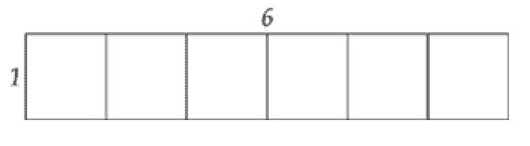

Ask how might a rectangle help you to think about solving multiplication with fractions?
Think about solving 6x1/2

Students should respond by suggesting the rectangle can be cut in half.

Ask which way we should cut the rectangle and model.

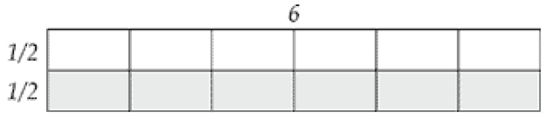

Explain the top half of the rectangle is six units by one-half unit and shows the problem six times one-half. The bottom shaded half shows the same problem again, but we don’t need to consider both. How many squares are there in the unshaded rectangle? Does this still give an answer of three?

Student should respond that two halves make a whole, and you do that three times, so the six halves make three whole squares. Three is still the answer.

Teacher should show the following equation to reflect the rectangle model.

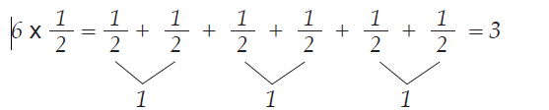

- Extending the experience

Online interactive fraction bars activity.

http://www.abcya.com/fraction_tiles.htm

Online practice problems for review.

http://www.mathscore.com/math/practice/Basic%20Fraction%20Multiplication/

Summarizing:

Ask students to review what facts they knew to be true about multiplication at the beginning of the learning experience. Compare and explain the difference between multiplying whole numbers vs. multiplying wholes and fractions.

Ticket out the door: Write a brief sentence or two explaining what do you understand now that you didn’t before?
Sources: Marilyn Burns Lesson on Math Solutions “Introduction of Multiplication of Fractions”

Did your plans you include the following?

Models (Concrete—Semi-Concrete—Semi-Abstract—Abstract)

Problems/Situations

Questions

