Learning Experience:

___Area and Perimeter____

When planning, include the following:

Models (Concrete—Semi-Concrete—Semi-Abstract—Abstract)

Problems/Situations

Questions

AKS:
38.MD.3. Apply the area and perimeter formulas for rectangles in real world and mathematical problems.

36.MD.2. Use the four operations to solve word problems involving distances, intervals of time, liquid volumes, masses of objects, and money, including problems involving simple fractions or decimals, and problems that require expressing measurements given in a larger unit in terms of a smaller unit. Represent measurement quantities using diagrams such as number line diagrams that feature a measurement scale.

Vertical Alignment:
3rd Grade
32.MD.5 recognize area as an attribute of plane figures and understand concepts of area measurement
33.MD.5 use words, pictures and/or numbers to show that "unit square" is a square with a side length of 1 unit, has an area of one square unit, and can be used to measure area of plane figures
34.MD.5 demonstrate that a plane figure which can be covered without gaps or overlaps by "n" unit squares is said to have an area of "n" square unit
35.MD.6 measure areas using unit squares by counting, adding, tiling and multiplying with models in square cm, square m, square in. and square ft.
36.MD.7 relate area to the operations of multiplication and addition
39.MD.7 use tiling to show in a concrete case that the area of a rectangle with whole-number side lengths a and b + c is the sum of a x b and a x c; use area models to represent the distributive property in mathematical reasoning
41.MD.8 solve real world problems involving the perimeters of polygons including finding the perimeter given the side lengths and finding an unknown side length

5th Grade
11.NBT.6 illustrate and explain division calculations by using equations, rectangular arrays, and/or area models
20.NF.4 find the area of a rectangle with fractional side lengths by tiling it with unit squares of the appropriate unit fraction side lengths, and show that the area is the same as would be found by multiplying the side lengths

34.MD.5 find the volume of a right rectangular prism with whole-number side lengths by packing it with unit cubes and show that the volume is the same as would be found by multiplying the edge lengths, equivalently by multiplying the height by the area of the base
35.MD.5 estimate, derive and apply the formula(V= l x w x h and V= b x h) for the volume of a cube and a right rectangular prism using manipulatives and relate volume to the operations of multiplication and addition to solve real world and mathematical problems

Standards for Mathematical Practice:

1. Make sense of problems and persevere in solving them.
2. Reason abstractly and quantitatively.
3. Construct viable arguments and critique the reasoning of others.
4. Model with mathematics.
5. Use appropriate tools strategically.
6. Attend to precision.
7. Look for and make use of structure.
8. Look for and express regularity in repeated reasoning.

Materials:

1-inch tiles (36 per student) or Cheez-Its Crackers
1 ruler or tape
Student Recording Sheet
2 copies of 1-inch grid paper
Napkins or paper towels

Vocabulary:
Area
Area model
Perimeter
Units
Rectangles
Table
Relationship
Formula
Line segments
Arrays
Measurement

Essential Question:

• How is perimeter different from area?
• What is the relationship between area and perimeter when the area is fixed?
• What is the relationship between area and perimeter when the perimeter is fixed?
• How does the area change as the rectangle’s dimensions change (with a fixed perimeter)?
• How are the units used to measure perimeter like the units used to measure area?
• How are the units used to measure perimeter different from the units used to measure area?

Activating Strategy:

YouTube Video: Math Rocks! Area & Perimeter

http://www.youtube.com/watch?v=D5jTP-q9TgI

Instructional Activity:
*Adapted from Georgia Department of Education Common Core Georgia Performance Standards Framework

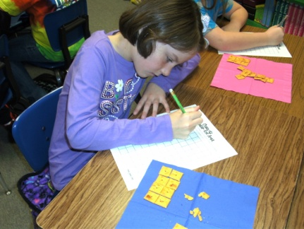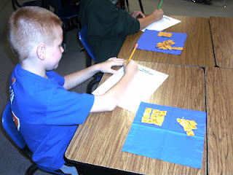

1. Instruct students to create a rectangle with a perimeter measuring 12 units with the tiles or Cheez-Its. (Use the grid paper to record results if desired). Have a student volunteer share their rectangle for all to see (may adapt to whatever technology is available in your classroom.) Students’ rectangles may be of the following whole unit dimensions: 1 x 5, 2 x 4, or 3 x 3

2. Ask students to find the area of their rectangle and to record in a table like the one used in Part 1.

3. Direct students to draw and find the area of all the rectangles they can that have a perimeter of 12 whole units. Ask about anything they notice about the relationship between the area and perimeter.

4. Direct the students to draw and find the area of all the rectangles they can that have a perimeter of 24 units. Rectangle dimensions will be: 1 x 11, 2 x 10, 3 x 9, 4 x 8, 5 x 7, and 6 x 6.

FORMATIVE ASSESSMENT QUESTIONS
• What did you notice about the perimeter?
• How does the perimeter change as the shape of the rectangle changes?
• What did you notice about the area?
• How does the area change as the rectangle’s dimensions change?

DIFFERENTIATION
Extension
• Give students more tiles and have them find the perimeter and area of all the possible rectangles they can create with the number given (possibly start with 48 tiles)

Intervention
• Start with one tile. Have the student record the dimensions of the rectangle and determine the perimeter and area. Record and sketch on the centimeter grid paper. Add one tile at a time for the students to determine the dimensions, perimeter, and area. Students should record their findings and sketch each rectangle on the centimeter grid paper.

- Expanding the experience
Area and Perimeter Part 2

Technology – Use whiteboards, student worksheet from link, or individual computers. http://transum.org/Software/SW/Starter_of_the_day/starter_September10.ASP

- Extending the experience
Everyday Math – Lesson 8.4 “What is the Total Area of My Skin?”

Summarizing:
Ticket Out the Door (TOTD)
- Create a Venn diagram comparing and contrasting area and perimeter.

Did your plans you include the following?

Models (Concrete—Semi-Concrete—Semi-Abstract—Abstract)

Problems/Situations

Questions

Name______________________________________________ Date ____________________

Perimeter and Area: Part 2

Solve the following problems.
1. The community center has decided to move the parking area to the back of the building and replace the front with a grass lawn. The lawn is rectangular shaped with a length of 10 yards and a width of 40 yards. A bag of grass seed covers 50 square yards at a cost of $4.99 per bag.

What is the total area of the new lawn?
How many bags of grass seed will they need to buy?
What is the total cost to renovate the front lawn with the new grass?

2. Mr. Ely keeps his chickens in a square pen with an area of 100 square feet. What is the length of one side of the chicken pen?

3. Ethan’s parents are re-carpeting his bedroom. The dimensions of the room are shown in the diagram.

How many square feet of carpet do they need to buy for the entire room?

Name______________________________________________ Date ____________________

Perimeter and Area: Part 1

Directions:
1. On your grid paper, draw a rectangle with a perimeter of 12 units.
2. Measure the outside dimensions and record in the chart below.
3. Calculate and record the measurements for area and perimeter.
4. Repeat for all the rectangles possible having a perimeter of 24 units.

Rectangle Dimensions | Area | Perimeter

